USMLE Review

- Recombinant DNA Techniques
  - Summary of Common Methods
1. Bacterial restriction enzymes (DNA endonucleases) can cut DNA into smaller pieces at defined sites.
2. Electrophoresis can separate nucleic acid molecules based on size.
3. DNA ligases can be used to join DNA fragments to create new combinations of DNA sequences (recombinant DNA). (e.g. inserting a DNA fragment into a self-replicating genetic element).
- Living cells (usually bacteria or yeast) can be used to make many copies of a DNA fragment. The fragment is first inserted into a self-replicating genetic element (cloning vector) such as a plasmid, bacterial virus or artificial eukaryotic chromosome. The recombinant vector is introduced into an appropriate cell and is replicated using the cell’s own DNA replication machinery. Alternatively, a DNA fragment can be replicated in a test tube using the polymerase chain reaction (PCR). The product can be analyzed to look for differences between individuals.
- Nucleic acid hybridization can be used to detect and specific DNA (Southern blotting) or RNA (Northern blotting) molecules. Hybridization is the principal behind the use of microarrays to determine changes in gene expression in human disease.
- DNA fragments can be sequenced, which makes it possible to predict the amino acid sequence of any protein encoded by that DNA.
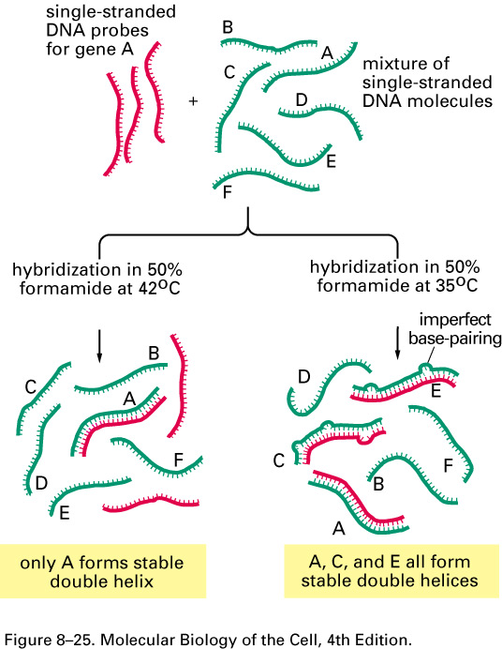
- A specific DNA fragment can be transcribed (used to synthesize RNA) and the resulting RNA translated to produce a protein, which can then be studied. These steps could be made to take place in a test tube, or the DNA can be inserted into an appropriate cell (bacteria, yeast, animal) and the protein recovered from the cell lysate or cell culture medium. Recombinant human proteins produced in this way have been used as drugs (e.g. human growth hormone, insulin, and erythropoietin).
Figure 8–25 Different hybridization conditions allow less than perfect DNA matching.

When only an identical match with a DNA probe is desired, the hybridization reaction is kept just a few degrees below the temperature at which a perfect DNA helix denatures in the
solvent used (its melting temperature), so that all imperfect helices formed are unstable. When a DNA probe is being used to find DNAs that are related, but not identical, in sequence, hybridization is performed at a lower temperature. This allows even imperfectly paired double helices to form. Only the lower-temperature hybridization conditions can be used to search for genes (C and E in this example) that are nonidentical but related to gene A.
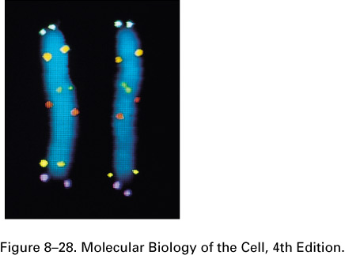
  - Clinical Uses of Hybridization
In situ hybridization to locate specific genes on chromosomes.
Here, six different DNA probes have been used to mark the location of their respective nucleotide sequences on human chromosome 5 at metaphase. The probes have been chemically labeled and detected with fluorescent antibodies. Both copies of chromosome 5 are shown, aligned side by side. Each probe produces two dots on each chromosome, since a metaphase chromosome has replicated its DNA and therefore contains two identical DNA helices. This general technique can be used to detect abnormalities of chromosome structure (clinical cytogenetics) such as deletions, rearrangements, etc.
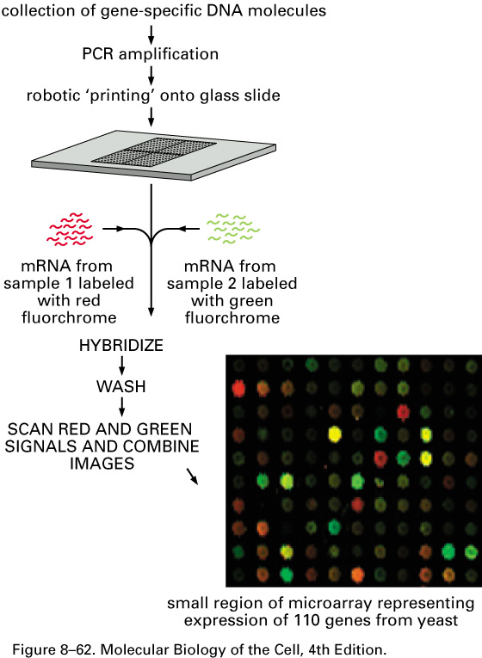
To prepare a microarray, DNA fragments, each corresponding to a gene, are spotted onto a slide by a robot. In this example, mRNA is collected from two different tissue samples for direct comparison. The mRNAs in these samples are labeled, mRNAs from Sample 1 (e.g. a human tumor) with a red fluorescent tag and mRNAs from Sample 2 (a corresponding normal tissue) with a green fluorescent tag. Equal amounts of the two samples are mixed and allowed to hybridize to the DNA fragments on the microarray. mRNAs will bind to their complementary DNAs at their specific positions on the plate. The fluorescence of each spot is measured at two wavelengths, one for red and the other for green. If a spot fluoresces red, it means Sample 1 contains more of the specific mRNA corresponding to the DNA at that spot location. If a spot fluoresces green, then Sample 2 contains more of that particular mRNA. If a spot is black, it means that neither sample had measurable amounts of the corresponding mRNA. A yellow spot means both samples contained equal amounts of the particular mRNA. A specific disease might be associated with a specific pattern of spots, making diagnosis easier.

  - Clinical and Forensic Uses of PCR
Diagnosis of Duchenne Muscular Dystrophy by multiplex PCR.

DMD GENE
i a g b c d e f h sites amplified
by PCR
e
f
cbhagd
i
e
f
c
b
h
a
g
d
i
5’ 3’

0 0.5 1.0 1.5 2.0 Mb

MW A B C D E F
Detection of DNA deletions of the DMD gene by multiplex DNA amplification (PCR). Diagram of the DMD gene indicating the relative location of the nine exon-containing DNA segments amplified with this procedure (arrows a-I). PCR primers were selected to give a range of product sizes that allowed for their separation by electrophorsis. The sequences targeted for PCR amplification are in regions most often deleted in DMD. The lower diagram is a representation of an agarose gel electrophoresis of PCR products from DMD males. MW contains molecular weight standards. The sample A is a normal control that does not contain any deletions. B-F are deleted in one or more regions. Samples C and F are deleted for all nine regions. (−) shows a negative control in which no DNA template was added to the PCR reaction. From top to bottom, the fragments correspond to regions e, f, c, b, h, a, g, d, and i, respectively.

PCR is used in forensic science to identify the source of a DNA sample and to determine relatedness (e.g. paternity)
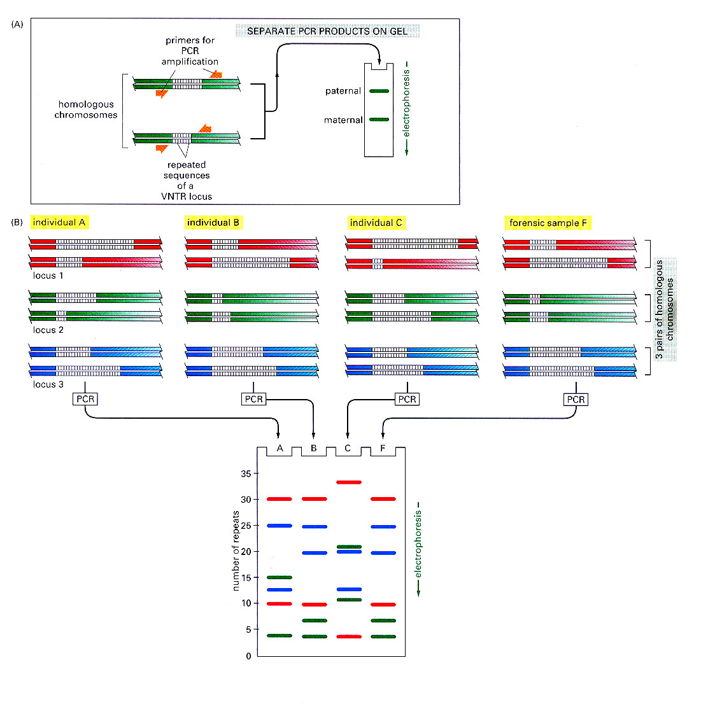

Within the human genome are regions that contain short repeated sequences, such as (CAC)_{n}. The length of these repeated sequences in highly variable between individuals, ranging from 4 to 40 for any given repeat, and it is inherited. A run of repeated nucleotides of this type is often referred to as a VNTR (variable number of tandem repeats) or alternative as a hypervariable microsatellite sequence. Individuals usually inherit different variants from their mothers and fathers. PCR, using primers that bracket the locus, gives rise to two bands (Fig. A), derived from the maternal and paternal chromosome. (B) The human genome contains many such VNTRs at different locations in the genome. By simultaneously performing PCR with several different primer pairs corresponding to particular VNTRs and separating the products by electrophoresis, banding patterns are obtained that are virtually unique to a given individual. When examining the variability at 5 to 10 different VNTR loci, the odds that two random individuals would share the same genetic pattern by chance can be as low as one in 10 billion. Here the pattern produced by DNA from individual B matches that of the forensic sample, (lane F).

  - Single Nucleotide Polymorphisms (SNPs) are common single nucleotide differences that exist between individuals at many locations in the genome. A given SNP allele might have no observable phenotype, but could have a subtle effect on the level or activity of a protein. Some diseases that have complex patterns of inheritance could be due to the presence of a specific constellation of SNPs, which collectively produce a propensity for a given disease. It is hoped that it will one day be possible to predict the likelihood of diseases that have complex causes from an individual’s pattern of SNPs.

- RNA Synthesis and Processing

A. RNA polymerase enzymes.

DNA-dependent RNA polymerases from animal cells.
Type Location Major RNA products
RNA polymerase I Nucleolus Pre-rRNA
RNA polymerase II Nucleoplasm hnRNA (pre-mRNA)
RNA polymerase III Nucleoplasm Pre-tRNA, 5S rRNA
7S scRNA
Mitochondrial Mitochondrial matrix mitochondrial RNA

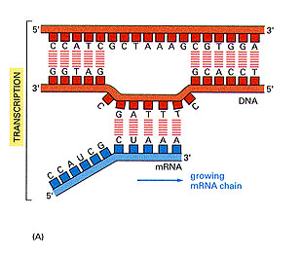
B. Promoters are DNA sequences required for gene transcription. They bind general transciption factors to recruit RNA polymerases to their respective genes. The promoter determines the location at which RNA polymerase will bind and thus the site at which transcription begins. Because the promoter is asymmetric, it also determines the orientation in which RNA polymerase will bind. The orientation of the polymerase determines in turn the direction the polymerase will move along the DNA and thus which of the two strands will be copied into RNA.
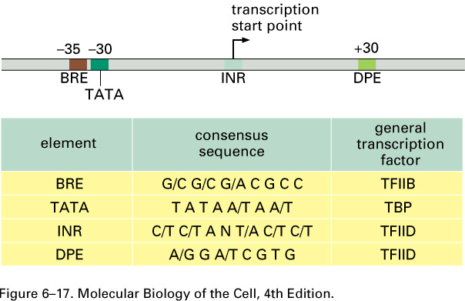
In this example, RNA polymerase is moving along the double-stranded DNA from left to right, copying the lower strand into RNA. Note that nucleic acids are always synthesized by adding nucleotides to the 3’ end of the growing chain (synthesis occurs in the 5’ to 3’ direction).

C. General Transcription factors participate in recruiting RNA polymerase to the gene.
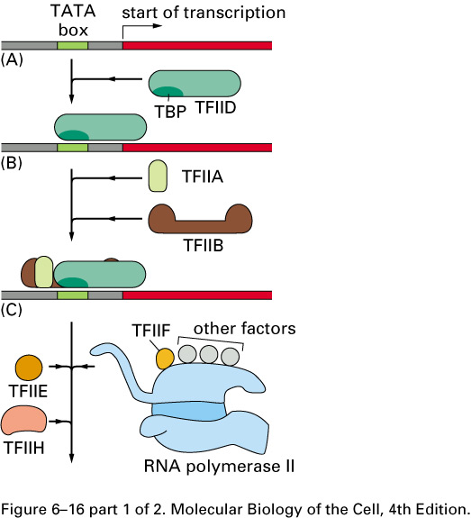
Model for Pre-initiation Complex (PIC) Assembly on a TATA-containing Core Promoter. TFIID, TFIIA and TFIIB bind to the promoter in an early step. TFIID is composed of the TATA binding protein (TBP) and TBP-associated factors (TAFs). A minimum set of basal factors (TFIIE, –F, and –H) and RNA polymerase II (Pol II) next bind in the order shown. CTD refers to the C-terminal domain of RNA polymerase II. TAFs, which make up the remainder of TFIID, have a variety of activities that facilitate transcription initiation. TFIIB helps determine the orientation (direction) of binding of TBP to the promoter. TFIIF inhibits nonspecific binding of the polymerase to DNA. TFIIH functions both as a helicase to unwind DNA (separate the DNA strands) and a kinase to phosphorylate the CTD of Pol II. Hyper-phosphorylation of the CTD releases Pol II from the initiation complex so that it is free to move down the DNA template and synthesize RNA.

CTD

PIC

D. A typical gene transcribed by RNA polymerase II and the final processed (mature) mRNA
Pre-initiation Complex
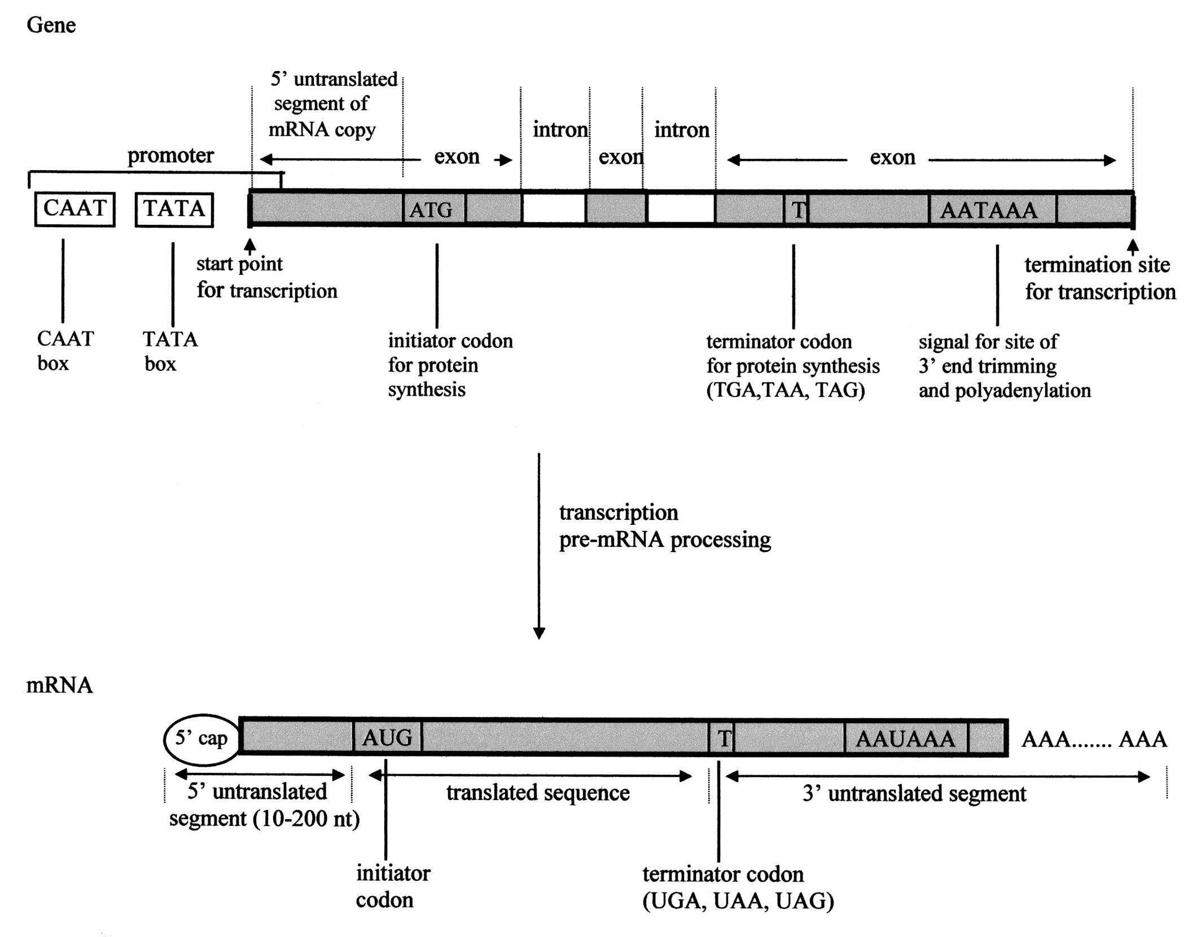

Summary of the steps leading from gene to protein in eucaryotes. The RNA initially produced by transcription contains both coding (exon) and noncoding (intron) sequences. Before it can be translated into protein, the two ends of the RNA are modified (the 5’ end is capped and the 3’ end is cleaved and polyadenylated) and the introns are removed by an RNA splicing reaction. The resulting mRNA is transported out of the nucleus to the cytoplasm where it is translated into protein.

Capping (attachment of m⁷GPPP) to the 5’ end
Addition of a poly (A) tail to the 3’ end
Splicing to remove introns

E. Nucleotide sequences that define an intron. Mutations in conserved sequences required for splicing can produce aberrantly spliced messages that are either rapidly degraded or else produce nonfunctional proteins.
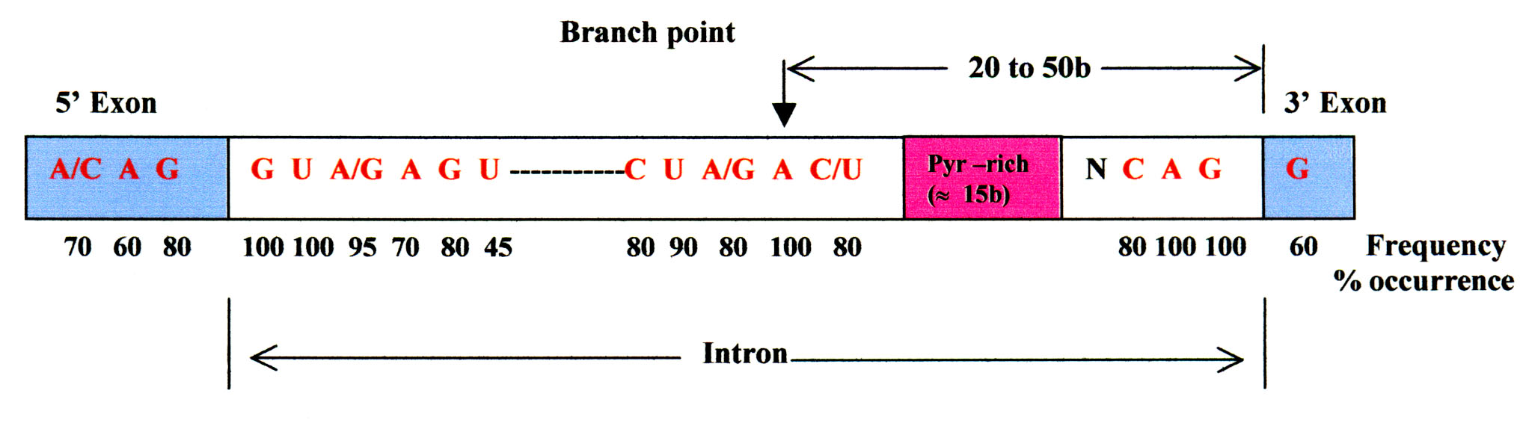
Branch point

F. Splicing of a pre-mRNA is catalyzed by five small nuclear ribonucleoprotein particles (snRNPs) together with associated splicing factors. These recognize features in the pre-mRNA required for splicing, assemble on the pre-mRNA, and catalyze the splicing reaction.
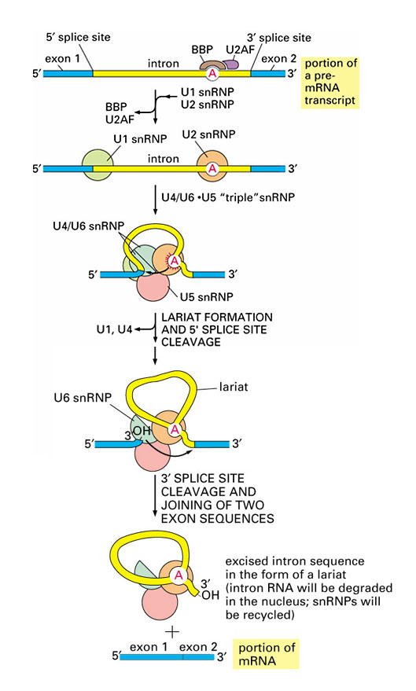

Assembly of the Spliceosome. Four sequence elements are necessary for the splicing of pre-mRNAs in higher eukaryotes: 5’ and 3’ splice sites, an adenosine residue that reacts with the 5’ end of the intron to release the preceding exon, and a polypyrimidine. Pre-spliceosome complexes are formed by the binding of U1snRNP to the 5’ splice site and U2 snRNP to the branch point region. The binding of U2snRNP is aided by branch point binding protein (BBP) and U2 auxiliary factor (U2AF)which binds the polypyrimidine tract. Binding of U2 to the branch point primes the adenine nucleotide for attack at the 5’ splice site. U4-U5-U6 tri-snRNP complex is next recruited to the pre-spliceosome, U1 and U4 snRNPs dissociate, and the end of the first exon is alternatively brought into contact with the branch point adenine nucleotide to form the lariat intermediate and the 3’ splice site to join the two exons.

III. Protein Synthesis
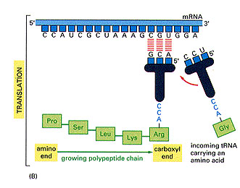
A. Transfer RNA (tRNA) functions as an adaptor that recognizes codons in an mRNA and delivers amino acids to the growing polypeptide chain. Protein synthesis involves 1) the attachment of amino acids to tRNAs (amino acid activation) and 2) the transfer of the amino acids to the growing polypeptide chain.
The nucleotides in the mRNA are matched three at a time to complementary sets of three nucleotides in the anticodon region of tRNA molecules. The tRNA molecules are adaptors that are also joined to amino acids. In this way, tRNAs bring amino acids to an mRNA. When codon-anticodon matching occurs, an amino acid is attached to the growing end of the polypeptide chain. Nascent RNA chains grow from the 5’ to 3’ end. Nascent polypeptide chains grow from the amino-terminal to the carboxyl-terminal end.
B. The genetic code is degenerate because many amino acids are encoded by more than one codon (e.g. there are six codons for leucine). The occurrence of nonstandard Watson-Crick base-pairing (wobble) between the bases in position 3 of the codon and position 1 of the anticodon allows some tRNAs to translate more than one codon.

- The genetic code is translated by two types of adaptors that act sequentially in protein synthesis. The first are the aminoacyl-tRNA synthetases that catalyze the attachment of amino acids to their corresponding tRNAs. The second are the tRNAs whose anticodons form base pairs with appropriate codons in an mRNA. An error in either step would cause the wrong amino acid to be incorporated into a protein chain.
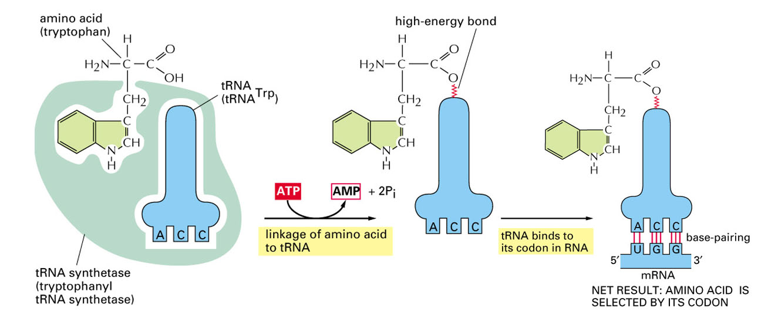

- Protein synthesis occurs in three phases, initiation, elongation and termination. Each phase is facilitated by protein factors, some of which are GTP-binding proteins. The rate of initiation appears to determine the overall rate of protein synthesis.
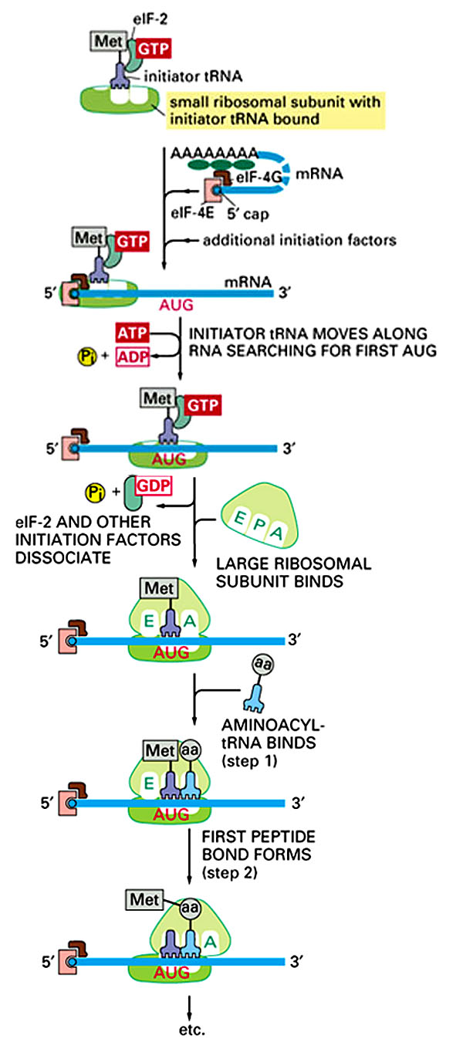
Initiation of protein synthesis in eucaryotes

1. 40S ribosomal binds a ternary complex between initiation factor 2 (eIF-2), GTP, and the initiator methionyl-tRNA (Met-tRNA^{i}) .

2. The mRNA is recruited to the complex formed in step 1 with the help of the cap-binding complex, eIF-4F and poly A binding proteins (dark green ovals). eIF-4F is composed of eIF4E, the cap binding protein, eIF-4G, a scaffold protein, and eIF-4A, a helicase (not shown). The 40S subunit scans the message for the first AUG codon, helped by the mRNA unwinding activity of eIF4A.

3. When an AUG codon is found, scanning ceases. eIF-5 binds (not shown) promoting the hydrolysis of the eIF-2-bound GTP, the association of the 60S subunit, and the ejection of eIF-2⋅GDP. This step also requires a second GTP-binding protein (eIF-5B, not shown) and hydrolysis of a second molecule of GTP.

This step also requires eIF5 and eIF5B⋅GTP (not shown)

An mRNA consisting of contiguous triplet codons can be read in three different reading frames, only one of which gives rise to the correct protein. Selection of the initiation codon (translation start site) determines the reading frame in which the message will be read.

- Protein synthesis is catalyzed by ribosomes. The ribosome insures the accuracy of the interaction between the anticodon of an aminoacyl tRNA with the codon of an mRNA. The ribosome also catalyzes the transfer of the amino acid to the growing polypeptide chain while moving forward along the mRNA three nucleotides at a time.
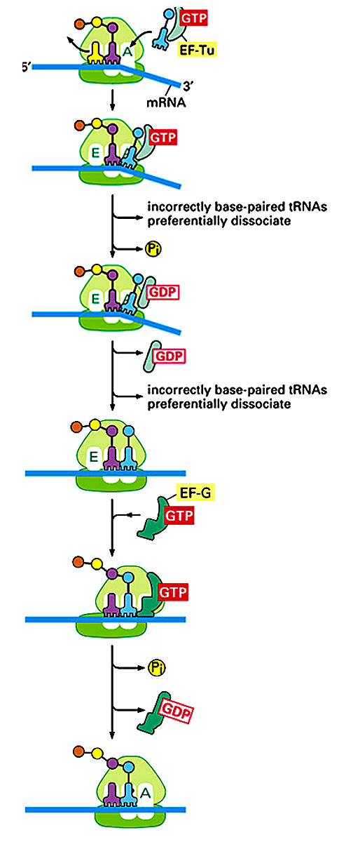
Elongation factors participate in the cycle of polypeptide chain elongation.

- The aminoacyl-tRNA is delivered to the A-site bound to the GTP-binding protein, EF-Tu (eEF-1α in eucaryotes). Correct codon-anticodon base-pairing triggers GTP hydrolysis, causing EF-Tu to dissociate from the aminoacyl-tRNA and allows peptide bond synthesis to proceed. Incorrect base-pairing delays GTP hydrolysis, giving time for the aminoacyt-tRNA⋅EF-Tu⋅GTP ternary complex to dissociate from the ribosome. A second delay occurs after GTP hydrolysis and prior to peptide bond synthesis in order to give an incorrectly base-paired aminoacyl-tRNA additional time to dissociate.
- After peptide bond formation (spontaneous), the binding of EF-G⋅GTP (EF-2⋅GTP in eucaryotes) promotes the movement of the ribosome along the mRNA by one codon. Following GTP hydrolysis, eEF-G dissociates from the ribosome, enabling the next cycle of elongation.
- When the ribosome reaches a stop codon, it is recognized by a release factor that binds the A-site of the ribosome. The completed polypeptide chain is released from the tRNA and the dissociation of the ribosome dissociates from the mRNA.

- Posttranslational Regulation of Gene Expression.
  - Regulation of gene expression can occur at multiple steps
Nucleus
Cytoplasm
Inactive mRNA

5

DNA
Primary RNA transcript
mRNA
mRNA

1
2
3
4
Protein
Modified or inactive protein
1 Transcription control
2 RNA processing control
3 Nuclear export control
4 Translation control
5 RNA stability control

6 Protein activity control

6

A. Alternative splicing gives rise to different forms of a protein from a single gene.
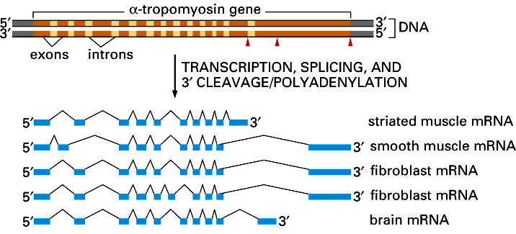

A
B

B. Translation can be regulated by phosphorylation of initiation factors
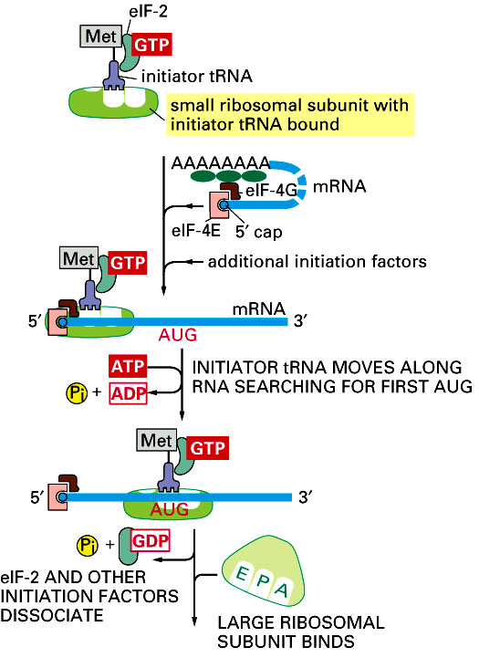
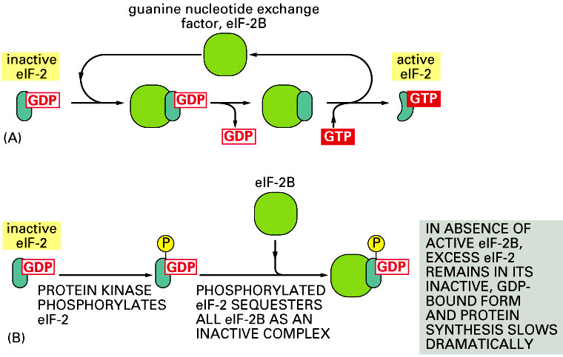

- The expression of a protein can be regulated at the level of degradation of its mRNA.
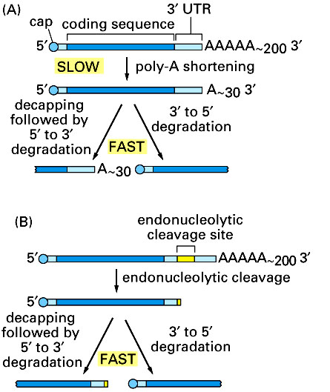

D. The expression of a protein can be regulated at the level of its degradation. Proteins targeted for destruction contain an amino acid sequence that is recognized by ubiquitinating enzymes. These enzymes add the small protein, ubiquitin, to the targeted protein. The ubiquitinated protein is then directed to a cytoplasmic, ATP-dependent protease called the proteosome. The protein is degraded and the ubiquitin is recycled.
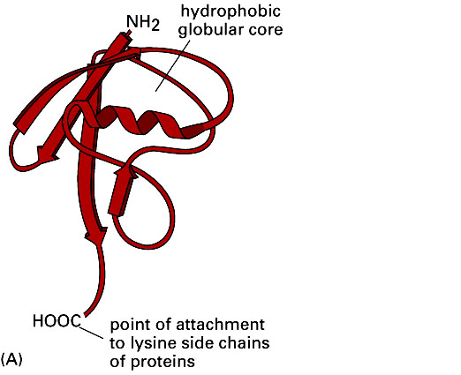
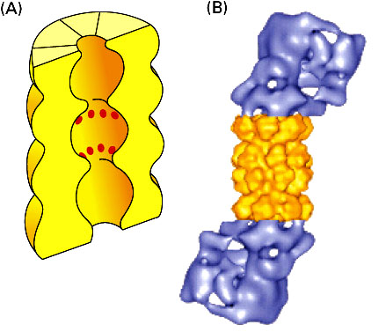

ubiquitin

Protease active sites

26S proteosome
Degradation of cell cycle regulators (cyclins) by the ubiquitin system

H₃N⁺–
–COO⁻

Cyclin A: -Arg-Thr-Val-Leu-Gly-Val -Ile-Gly-Asp-
Cyclin B1: -Arg-Thr-Ala-Leu-Gly-Asp-Ile-Gly-Asn-
Cyclin B2: -Arg-Ala-Ala-Leu-Gly-Glu- Ile-Gly-Asn-
Cyclin destruction box sequences

Amino acids and small peptides
Proteosome
Ubiquitin ligase

Ubiquitin

- Membrane Structure and Function
A. The lipid bilayer forms the basis of all cellular membranes. It is thin, flexible, self-sealing and impermeable to ions and other polar solutes. The bilayer is composed of three lipid types, phosphoglycerides, sphingolipids and cholesterol. Sphingolipids come in two flavors, phosphospingolipids, which resemble phosphoglycerides, and glycosphingolipids, which contain one or more sugar molecules in place of phosphorylcholine. Phosphoglycerides and sphingolipids can spontaneously aggregate to form a lipid bilayer.

  - Lipid bilayers can undergo a phase transition from a liquid crystalline to a gel crystalline state. This transition is accompanied by a decreased fluidity and deformability of the membrane
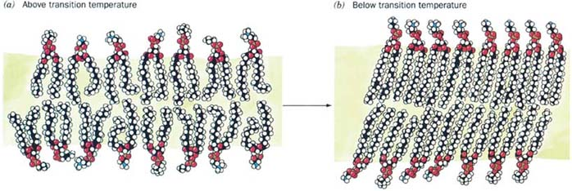

Liquid crystalline state
Gel crystalline state

Cholesterol can intercalate between neighboring phosphoglyceride or sphinoglipid molecules in the bilayer. Cholesterol exerts two effects; it prevents crystallization of the membrane while also decreasing the fluidity and deformability of the membrane. This latter effect produces a more stable bilayer that is less permeable to solutes.
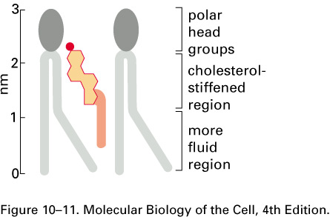

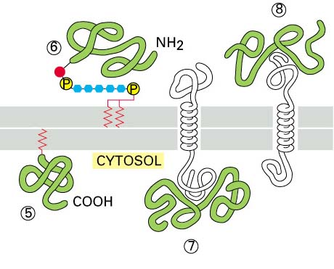
C. Membrane proteins are found in a variety of orientations in a bilayer

D. Biological membranes are asymmetric.
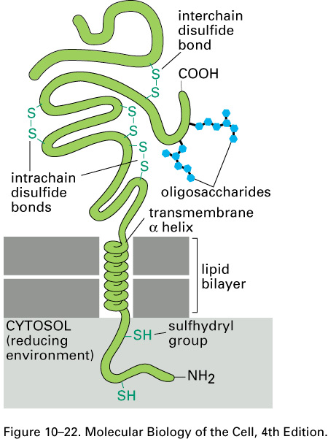
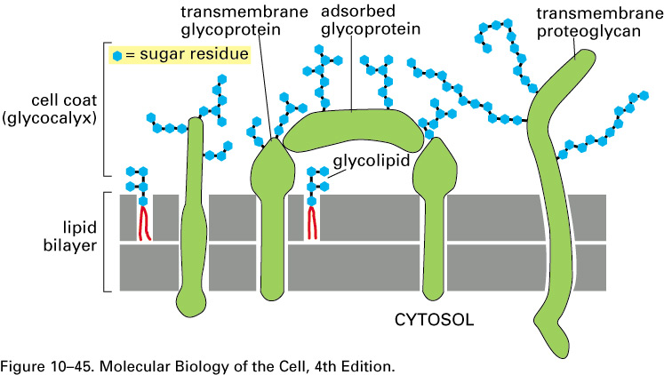

E. The common blood types are determined by the presence or absence of a single sugar

Sphingosine
Fatty Acid
Glc
Gal
Gal
GalNAc
Fuc
Glc
Gal
Gal
GalNAc
Fuc
GalNAc
Glc
Gal
Gal
GalNAc
Fuc
Gal
O Antigen
A Antigen
B Antigen

F. The lipid bilayer is permeable to hydrophobic molecules and small, uncharged polar solutes. However, the bilayer is impermeable to various ionic species and to the large, uncharged polar solutes that are the nutrients, metabolic intermediates or required cofactors for normal cellular function. Therefore, biological membranes contain various types of transport proteins (channels and carriers) that facilitate the selective movement of these types of materials across the plasma membrane or between various membrane-bounded intracellular organelles.

A comparison of channels and carriers

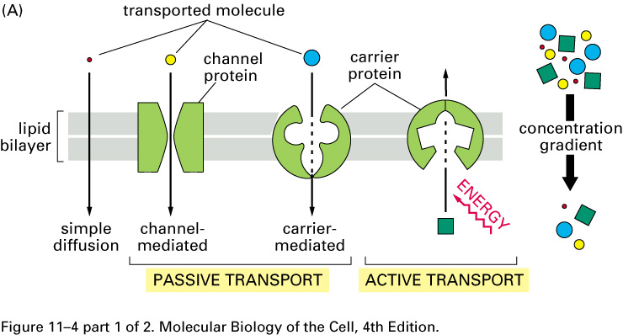

G. Carriers undergo a cycle of conformational change, alternately open to one side and then the other. When channels open, they are opened to both sides of the membrane at the same time. Consequently channels can support a much higher rate of solute transport than can carriers. A characteristic of facilitated transport is that is shows saturation kinetics with respect to the concentration of the transported solute.
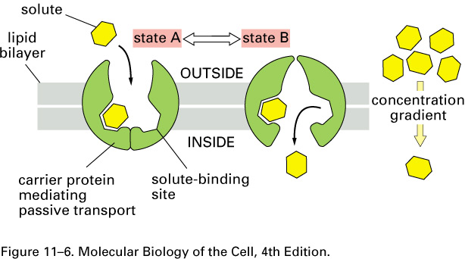
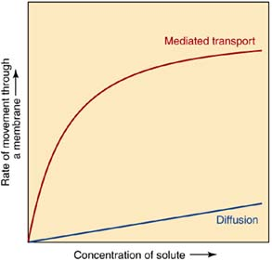

H. Classes of transporters: uniport vs. coupled transport
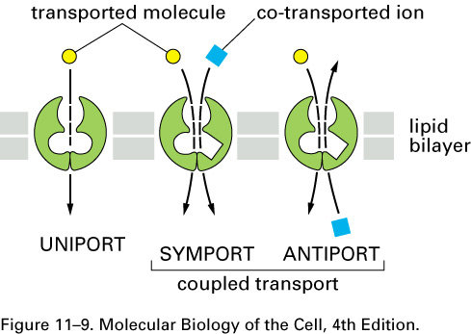

I. Types of active transport
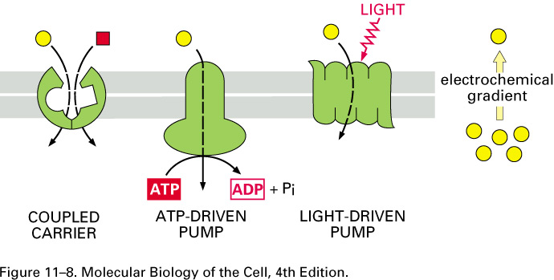

J. Examples of active transporters
1. ATP-dependent ion pumps (ATP-dependent Na⁺/K⁺ pump)
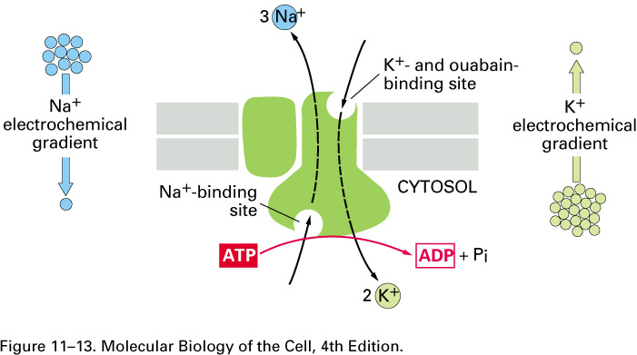

2. Sodium dependent co-transporters (sodium-glucose symporter)
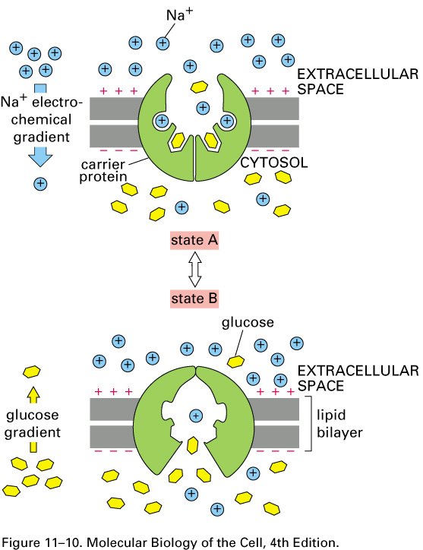

3. ABC Transporters – These constitute the largest class of ATP-dependent transport proteins and they are of great clinical importance. Members of this class are overexpressed in upto 40% of human cancers and are responsible for their multidrug resistance. A similar protein in the parasite Plasmodium falciparum confers their resistance to the common antimalarial drug chloroquine. Another family member participates in chloride transport and is defective in cystic fibrosis.
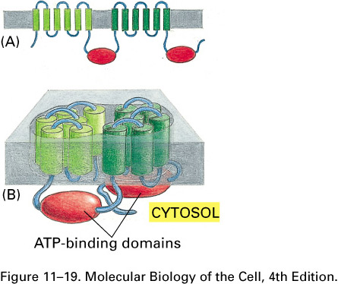

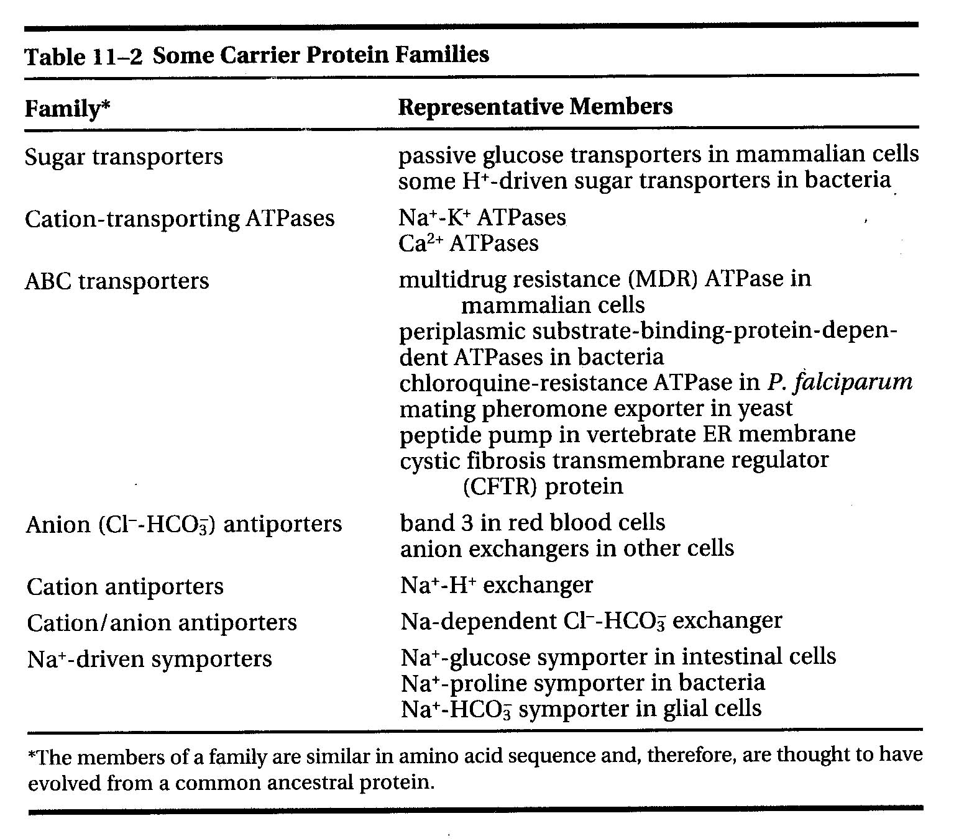

  - Intracellular Protein Traficking
A. Principal: The interior of eucaryotic cells is divided by membranes into a variety of specialized compartments or organelles. The vast majority of cellular proteins are synthesized on ribosomes in the cytosol. An organelle-associated protein must cross a membrane in order to be delivered to its correct final destination. This requires an organelle-specific targeting signal (signal peptide) contained within the amino acid sequence of the protein, and an organelle-specific device composed of a receptor that recognizes the appropriate signal and a protein translocator (mitochondria and endoplasmic reticulum) or gated pore (nucleus) that transports the protein through the membrane.

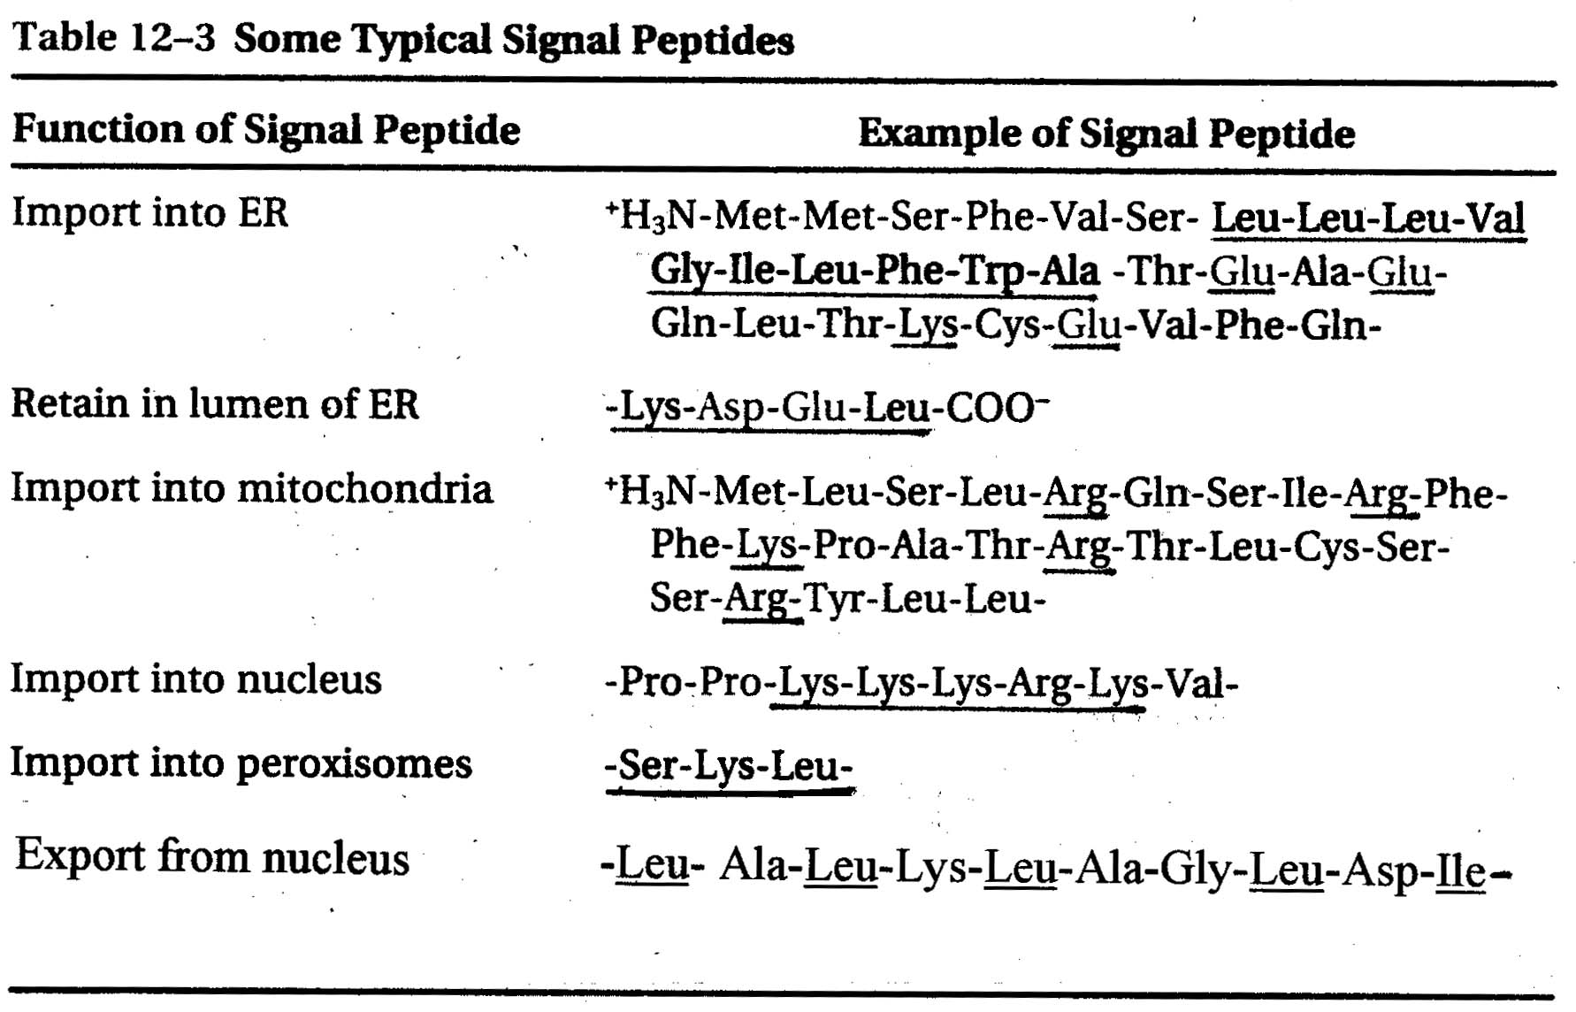
B.

C. Transport through the nuclear pore can be bi-directional. Proteins targeted to the nucleus contain a nuclear localization signal (Table) and interact with nuclear import receptors in the cytosol. Ribonucleoproteins (e.g. ribosomal subunits and mRNA-protein complexes) contain nuclear export signals and interact with nuclear export receptors in the nuclear matrix. The resulting complexes bind protein components of the nuclear pore (nucleoporins) and are transported through the pore. Ran, a monomeric GTPase, drives directional transport through the nuclear pore.
Nuclear Import

Cytoplasm Nuclear Nucleus
Low Ran-GTP membrane High Ran-GTP
GDP
RanGAP

Export Receptor
Cargo
Ran
RanGEF
GDP
GTP
Cytoplasm Nuclear Nuclear Matrix
Low Ran-GTP membrane High Ran-GTP
GTP
GTP

GEF – Guanine nucleotide exchange factor

GAP – GTPase activating protein

Nuclear Export

Cytoplasm Nuclear Nucleus
Low Ran-GTP membrane High Ran-GTP
GDP
GTP
RanGAP

RanGEF
GDP
Export Receptor
Cargo
Ran
GTP
GTP
Cytoplasm Nuclear Nuclear Matrix
Low Ran-GTP membrane High Ran-GTP

GEF – Guanine nucleotide exchange factor

GAP – GTPase activating protein

- Mitochondrial protein import usually requires an amino terminal mitochondrial signal peptide that interacts with protein translocators in the outer and inner mitochondrial membranes called TOM and TIM respectively. Once the protein enters the mitochondrial matrix, the signal peptide us usually removed by a signal peptidase.
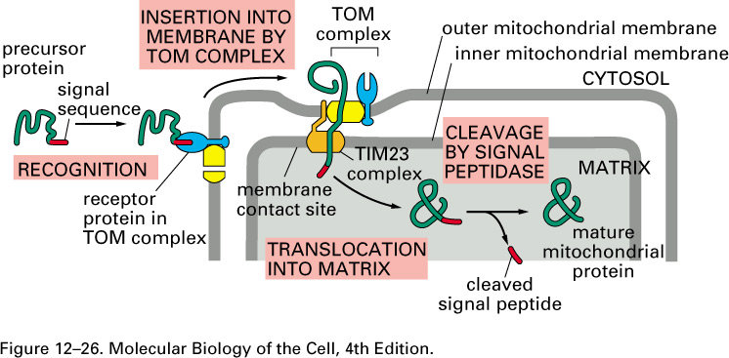

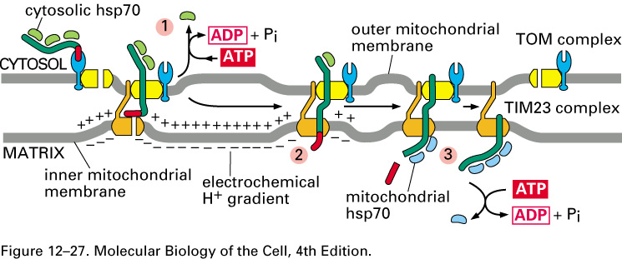
The energy required for protein import is in two forms, an electrochemical proton gradient created by mitochondrial respiration, and ATP hydrolysis required for the release cytosolic and mitochondrial hsp70 from the unfolded protein during the import process.

E. The peroxisome is an organelle that uses molecular oxygen to oxidize a variety of substrates, including fatty acids and cholesterol. The peroxisome, along with the cytochrome P₄₅₀ system in the smooth ER, also participates in the degradation of foreign substances. For example, ethanol is oxidized in peroxisomes to acetaldehyde. Peroxisomes import their enzymes after they are made in the cytosol. Some drugs used to lower blood lipid levels act by increasing the synthesis of the lipid transporters and lipid oxidative enzymes found in peroxisomes. A number of rare genetic diseases of peroxisomal biogenesis are known. The first one to be described, Zellweger ccerebrohepatorenal syndrome, results from a defect in protein import into peroxisomes. It name reflects the severe multiorgan consequences of the genetic defect.

F. Protein transport into the lumen of the endoplasmic reticulum occurs simultaneous with protein synthesis (cotranslational transport).
SRP receptor
Sec61 protein translocator complex
SRP, signal recognition particle
signal peptide
signal peptidase

Membrane proteins have their transport interrupted.

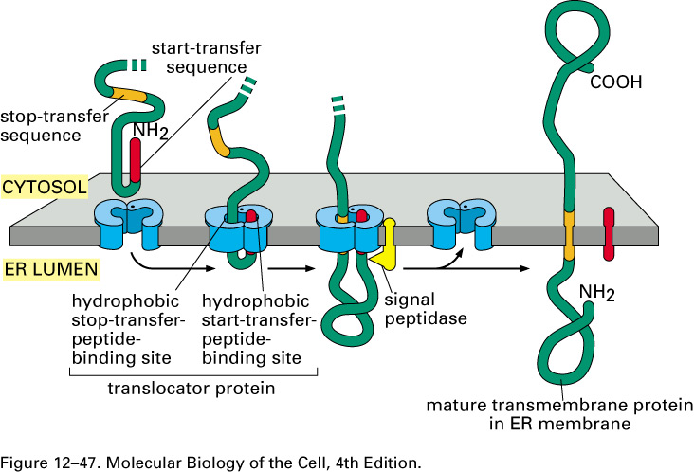
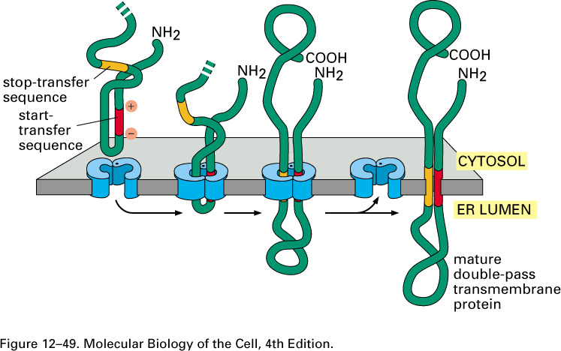
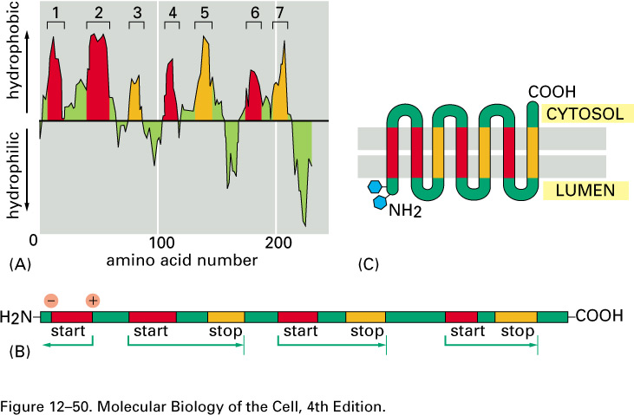

G. Proteins that enter the ER are glycosylated on asparagine residues in sequence Asp-X-Ser/Thr. The oligosaccharide chain attached to the protein is rich in the sugar mannose.
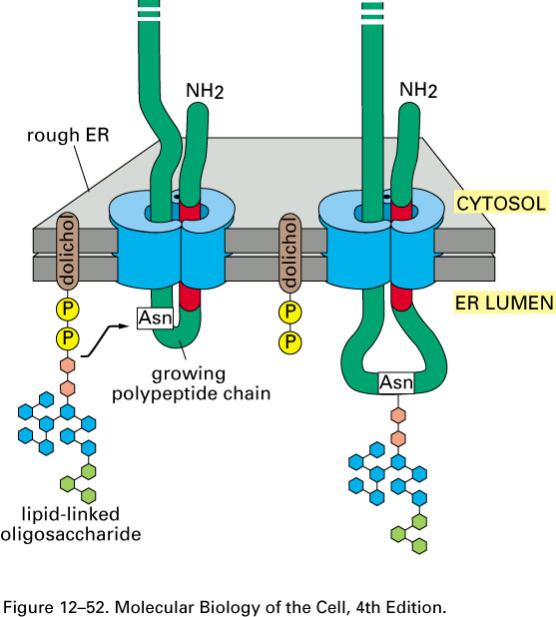

H. Proteins are transported from the ER to the Golgi apparatus. There they traverse a series of compartments where they undergo modification of their oligosaccharide chains and are eventually sorted for delivery to their final destinations (lysosomes, plasma membrane, or secretory storage granules).
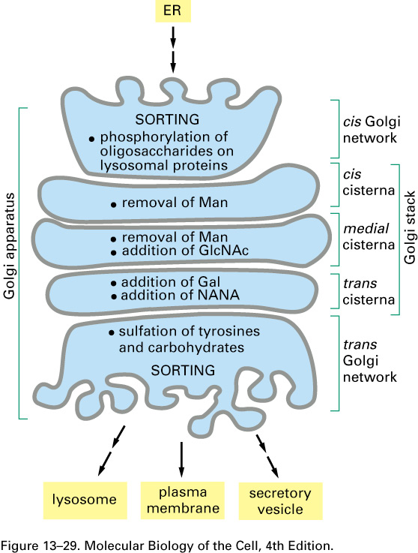

I. Proteins are transported between various intracellular compartments in small vesicles that bud from the membrane of the donor organelle and fuse with the membrane of the acceptor organelle. Three types of protein coats (COPI, COPII, and Clathrin) participate in the formation of transport vesicles, and their assembly in regulated by the monomeric GTPases, Sar1 and Arf. The function of the protein coat is to facilitate the formation of the membrane bud and to regulate the composition of the vesicle (proteins in the membrane and lumen of the vesicle).
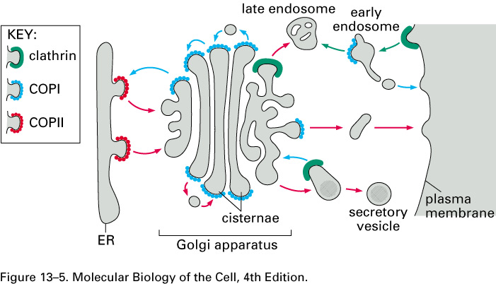
Sar
Arf
Arf

The assembly of a COPII-coated vesicle mediated by Sar1
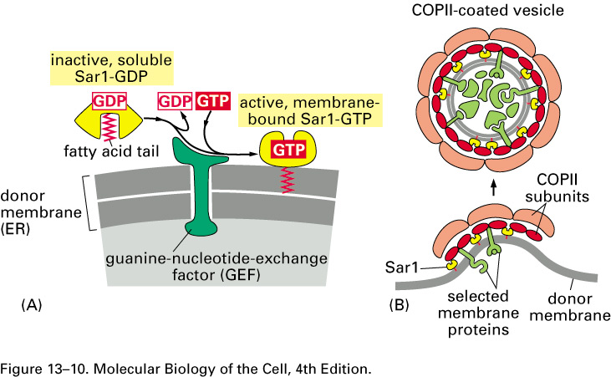

J. Specificity (selectivity) in vesicle transport and fusion with target membranes is achieved with the cooperation of two families of proteins, monomeric GTPases called Rabs and fusion proteins called SNAREs. For the sake of clarity, the assembly of the protein coat (COPI, COPII or clathrin) on the budding vesicle has been left out of the diagram.
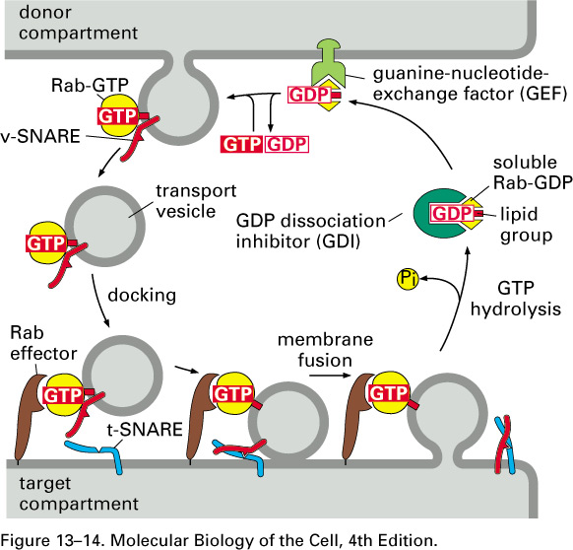

K. Clathrin-coated vesicles participate in the biogenesis of lysosomes, the formation of secretory vesicles and in receptor-mediated endocytosis. The form with the help of accessory proteins called adaptins.

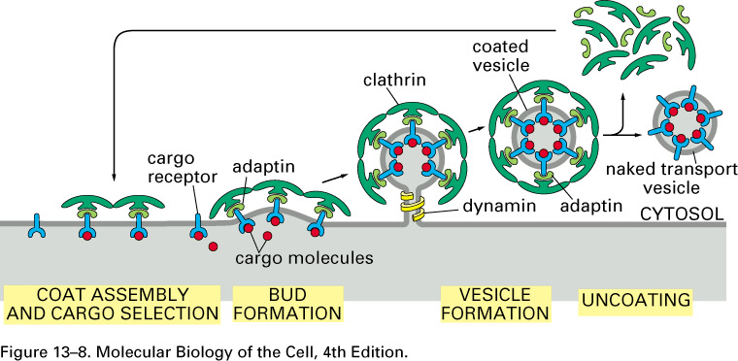

VII. The Biogenesis of lysosomes and Receptor Mediated Endocytosis
A. Lysosomes are degradative organelles that receive extracellular macromolecules and larger supermolecular structures that have been taken up by phagocytosis (e.g. leukocytes and macropages) and or endocytosis (most cells). Intracellular components can also be delivered to lysosomes by a process called autophagy. Within lysosomes, biopolymers can be hydrolyzed to their simpler constituents (sugars, amino acids, fatty acids, etc.). Lysosomal enzymes are synthesized on the rough endoplasmic reticulum, are phosphorylated on mannose residues in the cis-Golgi, and are transported to lysosomes from the trans-Golgi network with the help of mannose 6-phosphate receptors. Lysosomal enzymes are initially delivered to an intermediate compartment, the endosome, on the way to the lysosome. Within the endosome, the lysosomal enzyme dissociates from its receptor, and the receptor is returned to the trans-Golgi network. Lysosomal enzymes that are inadvertently secreted are returned to the lysosome by receptor-mediated endocytosis.
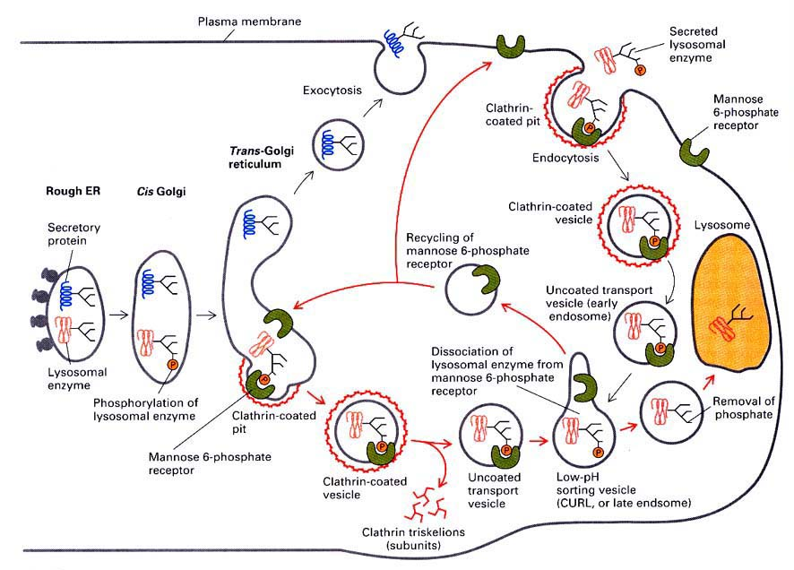

I-Cell disease or Mucolipidosis II is a rare genetic disorder characterized by severe psychomotor retardation and progression to death by ages 5 to 8. It results from a defect in the enzyme that catalyzes the first step in the phosphorylation of lysosomal enzymes in the cis-Golgi. The disease is characterized by the accumulation of undegraded glycolipids and polysaccharides in the lysosomes of cells of most tissues, leading eventually to cell death and organ failure.

B. Receptor Mediated Endocytosis of Low Density Lipoproptein (LDL).
The elevated serum cholesterol that is associated with an increased risk of cardiovascular disease and stroke results from increased levels of circulating LDL. Serum levels of LDL are controlled in part by its removal by receptor-mediated endocytosis. One in 500 individuals are heterozygous for a mutation in the LDL receptor that results in impaired LDL uptake, and these individuals have a twofold elevation in plasma cholesterol.
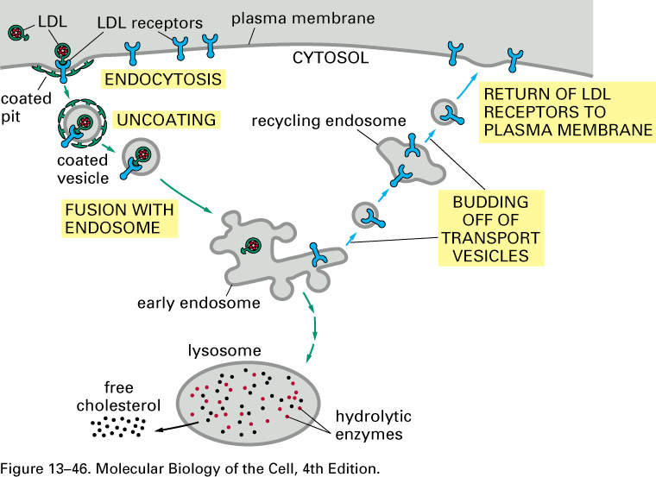

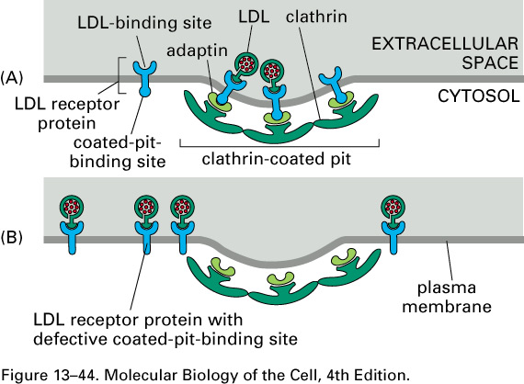

C. Intracellular signaling from some hormone receptors can be terminated by targeting the receptor for degradation in the lysosome.
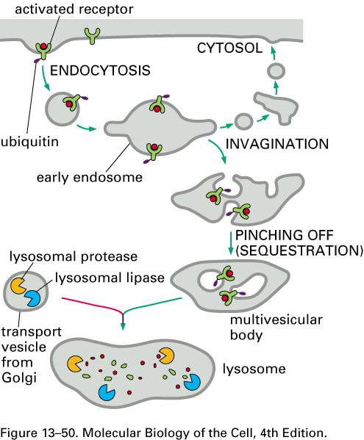

VIII. Oxidative Phosphorylation and Mitochondrial Genetics
A. Mitochondria are the principal sites of oxidation of pyruvate and fatty acids, and the formation of ATP. Both pruvate (pyruvate dehydrogenase) and fatty acids (β-oxidation pathway) are first oxidized to acetyl-CoA. The acetyl-group is then ozidized to CO₂ and water by the enzymes of the citric acid cycle. Nicotinamide adenine dinucleotide (NAD⁺) and flavin coenzymes (FAD or FMN) are the initial oxidants, generating NADH and FADH₂ or FMNH₂. The reoxidation of the reduced cofactors by a chain of electron carriers in the inner mitochondrial membrane provides the energy to synthesize ATP.

C-16 fatty acid + 7 NAD⁺ + 7 FAD + 8 CoA 8 acetyl-CoA + 7 NADH + 7 FADH₂
mitochondrial matrix
Glucose + 2 NAD⁺ 2 pyruvate + 2 NADH + 2 H⁺ cytosol

2 pyruvate + 2 NAD⁺ + 2 CoA 2 acetyl-CoA + 2 NADH + H⁺ mitochondrial matrix
Pyruvate is formed in the cytosol from glucose and is converted to acetyl-CoA in the mitochondrial matrix
Fatty acids are attached to CoA in the cytosol and oxidized to acetyl-CoA in the mitochondrial matrix

B. The citric acid cycle
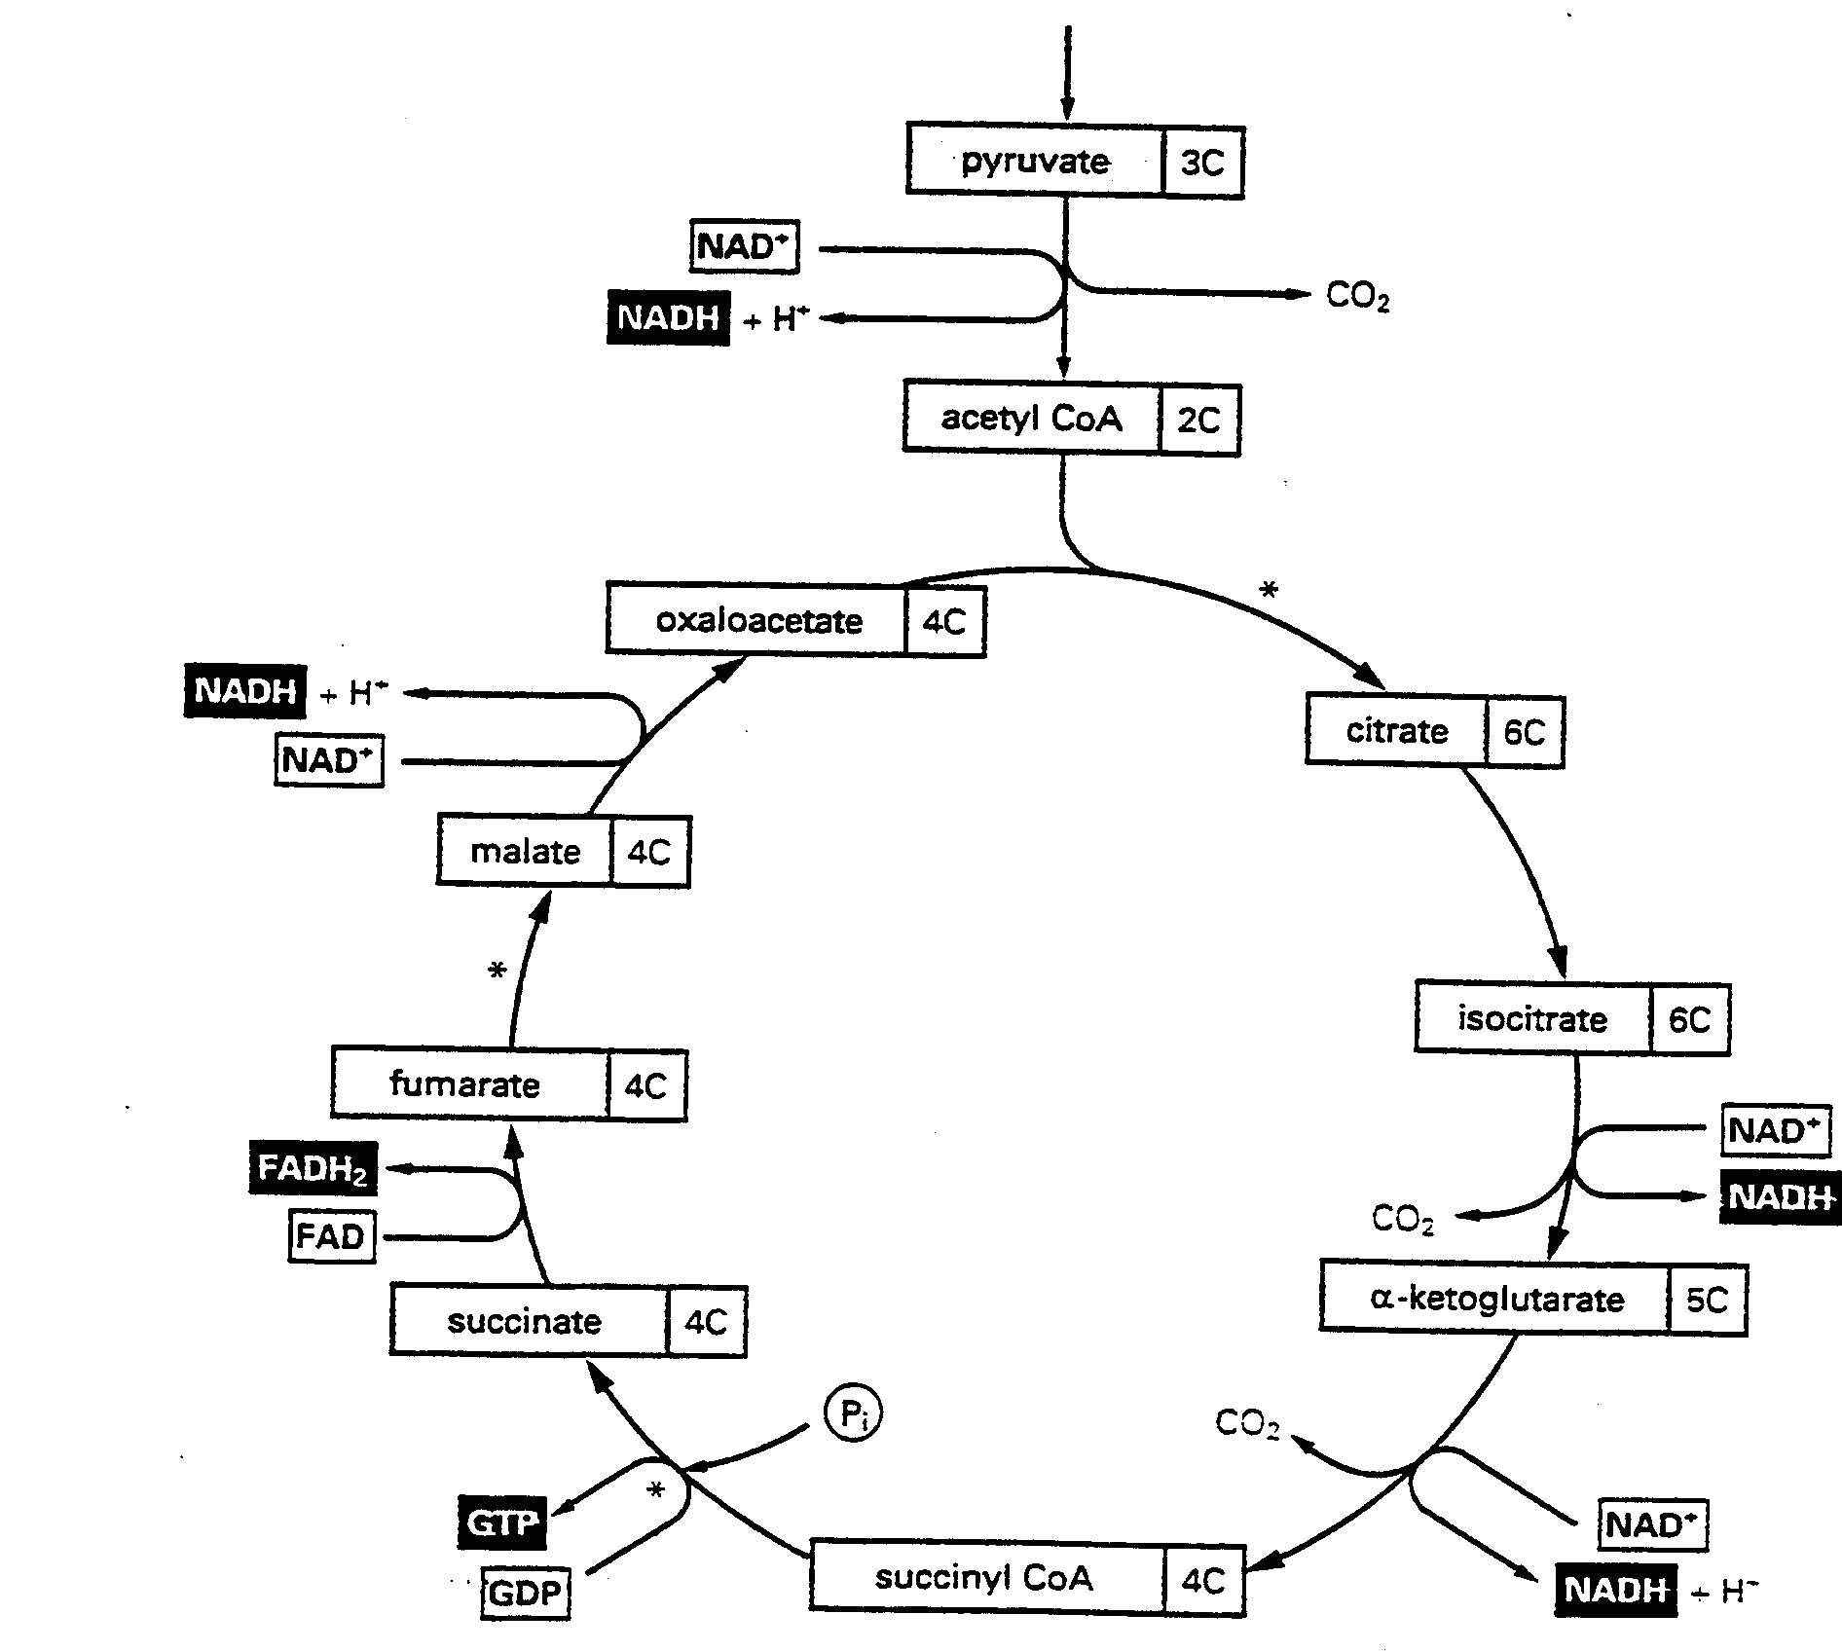
The cofactors NAD⁺ and flavin coenzyme are derived from the vitamins niacin and riboflavin respectively.

The enzymes pyruvate dehydrogenase and α-ketoglutarate dehydrogenase require five cofactors: NAD⁺ (shown), FAD, thiamine pyrophosphate (from the vitamin thiamine), lipoamide (from lipoic acid) and coenzyme A (from pantothenate)
Pyruvate dehydrogenase
Citrate synthase
Aconitase
α-keotglutarate dehydrogenase
Succinate thiokinase
Succinate dehydrogenase
Malate dehydrogenase
Fumarase

C. Bioenergetics and Oxidative Phosphorylation – ATP as a medium of energy exchange
Mitochondria Cytosol and other Compartments
Metabolic Fuel
ATP
Oxidation
Phosphorylation
CO₂ + H₂O
ADP + P₁
energy
ATP
ADP + P₁
Hydrolysis
energy
Work

Components of the Mitochondrial electron transport chain located in the inner mitochondrial membrane
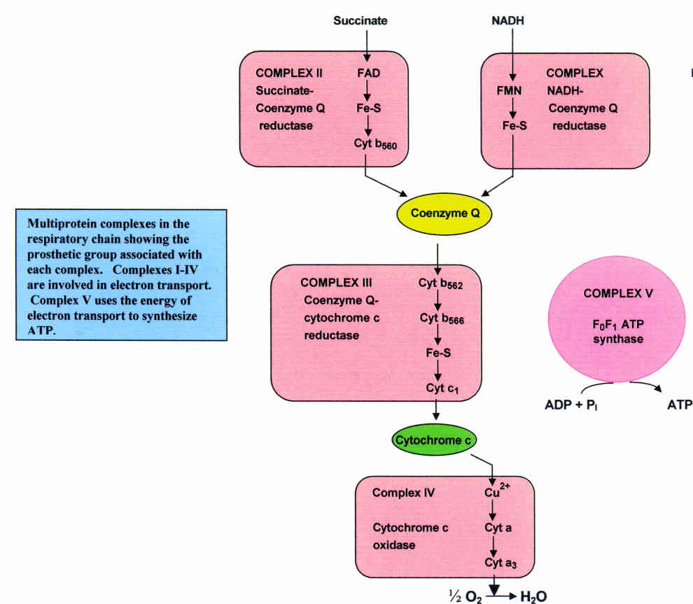

D. Mechanism of ATP generation
Complex I, III and IV of the electron transport chain also function as proton pumps during electron transport. Their combined action generates a membrane potential, negative inside, and a pH gradient, alkaline inside. These comprise a “proton-motive force” that drives the inward flow of protons through the F₀-F₁ ATP synthase, activating it to synthesize ATP.
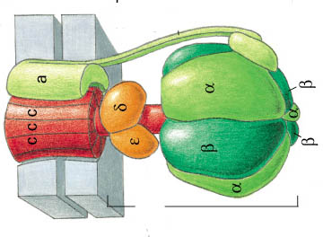
Intermembrane matrix (alkaline, negative)
space
H⁺
H⁺
H⁺
H⁺
H⁺
H⁺
H⁺
H⁺
ADP + P_{i}
ATP
pH gradient
ΔpH, inside alkaline
ATP synthesis driven by proton-motive force
Membrane potential
ΔΨ, inside negative

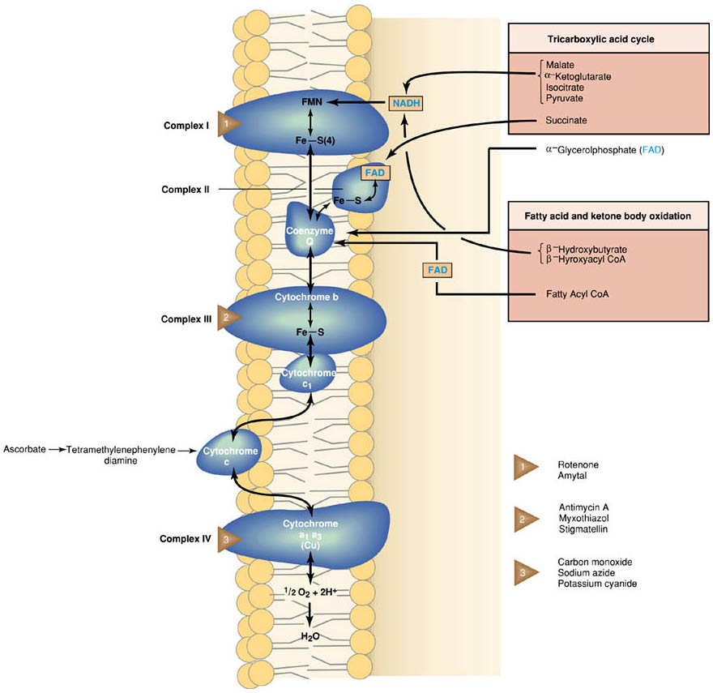

E. Human mitochondria contain 5 to 10 copies of a small circular chromosome that contains 2 mitochondrial rRNA genes, 22 mitochondrial tRNA genes and 13 mitochondrial protein encoding genes. Mutations in mitochondrial DNA produce a number of known human diseases. These often result in muscle and neurosensory abnormalities.

Mitochondria are inherited exclusively from the mother in humans. Thus, mutations in mitochondrial DNA are inherited by all children (male and female) of an affected mother, but only daughters can in turn pass the disease on to their children. Mitochondrial genes are inherited in a non-Mendelian fashion (cytoplasmic inheritance). As a result, siblings of an infected mother can demonstrate differences in the severity and manifestations of the disease (see below).
Mitochondria are inherited in a non-Mendelian manner through random distribution to daughter cells
Meiosis

Mutant
Mitochondrion
Normal mitochondrion
germ cell

eggs

Germ cells with different gene doses can produce tissues that are differently affected by the mutation

Different Tissues
Mutant
Mitochondrion

Normal mitochondrion
Meitosis
Fertilized
egg

Stem cells

